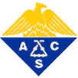
American Chemical Society

OFFICE OF THE PRESIDENT 1155 SIXTEENTH STREET, N.W.
WASHINGTON, D.C. 20036
William F. Carroll, Jr. Phone: (202) 872-4461
President-Elect, 2004 Fax: (202) 872-6338
President, 2005
Immediate Past President, 2006

November 11, 2004

Mr. Martim Afonso Penna
c/o Clorosur

Dear Martim:

On behalf of the American Chemical Society, I want to extend our warmest congratulations on the tenth anniversary of the Chemistry Olympics in Brazil. I’m very pleased with the leadership shown by Abiquim and Abiclor and the other supporters of chemistry education in Brazil.

I would like to personally thank the state coordinators of the program, and offer special recognition to the national coordinator of the program - Professor Sérgio Maia Melo, from Universidade Federal do Ceará and the vice-coordinator - Professor José Arimatéia Dantas Lopes, from Universidade Federal do Piauí.

I realize that this year’s contest is close at hand. My best wishes for a wonderful competition and thank you once again for your commitment to chemistry and education.

Very truly yours,

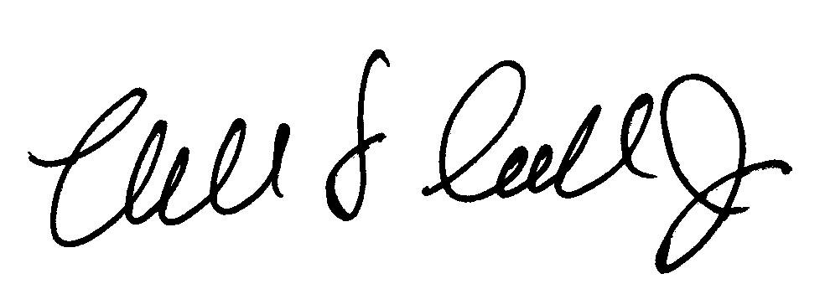

William F. Carroll, Jr.
President-Elect, 2004

